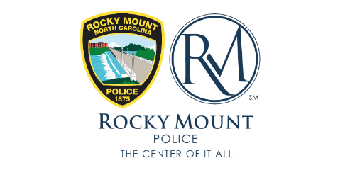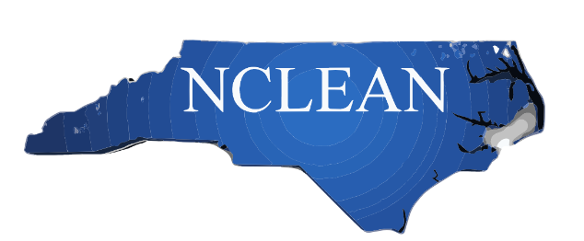

NCLEAN and the Rocky Mount Police Department are sponsoring a three-day training session on the accreditation software PDMS. Instruction will start with the beginning steps for use of the software program. The training sessions will be capped at 60 people. The training will be held in the Booker T Theater, 170 E Thomas St, Rocky Mount, NC 27801. Class will be from 8:30 to 5:30 each day with an hour for lunch on your own. A block of rooms has been set aside at the Tru by Hilton, 255 Gateway Blvd, Rocky Mount, NC 27804. The rooms are $107 plus tax a night, and this includes a free hot breakfast. Block rates are good through February 8, 2023. Rooms will be held for the group through March 24 but the price may increase after the 8th. Please call the hotel and refer to the NCLEAN rooms when booking.
Hotel Website: //www.hilton.com/en/hotels/rwimiru-tru-rocky-mount/
Hotel Phone: 252-618-0022
Group Name: NC LEAN
Please fill out the below information and submit this form along with $40.00 registration fee to Ricky Buchanan at rdbuchanan2@ncdot.gov. The facility will have free city wifi. It is recommended attendees bring their own mifi or wifi device. Power strips and/or drop cords would also be beneficial.
Attendee Name | Agency | Registration Fee
 |  | TOTAL

